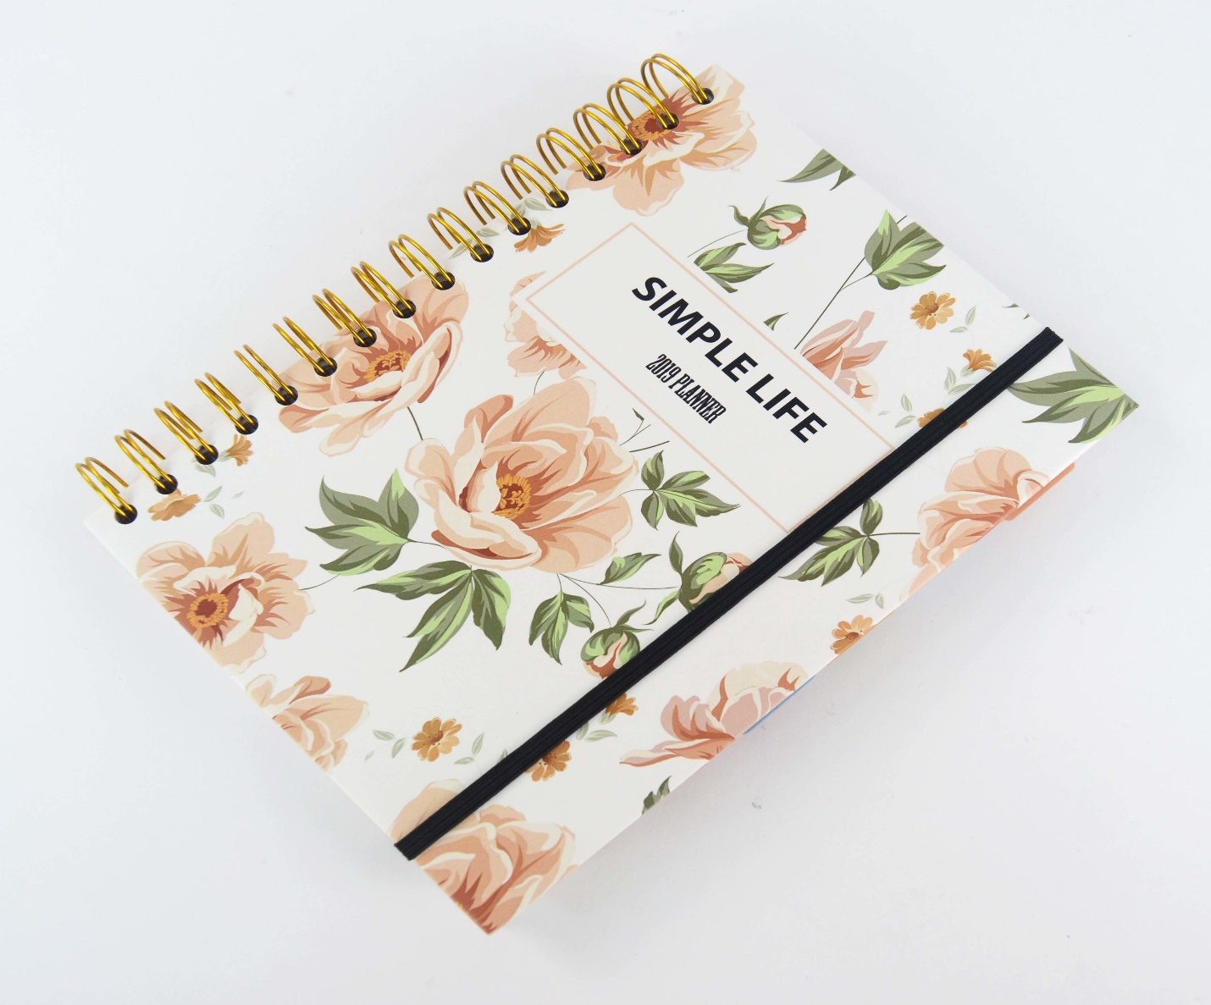

FLORAL MONTHLY PLANNER

RYANA CALENDARS is selling wonderful FLORAL diaries in different colors and designs! It contains of great DESIGNS on the cover !

RS 670